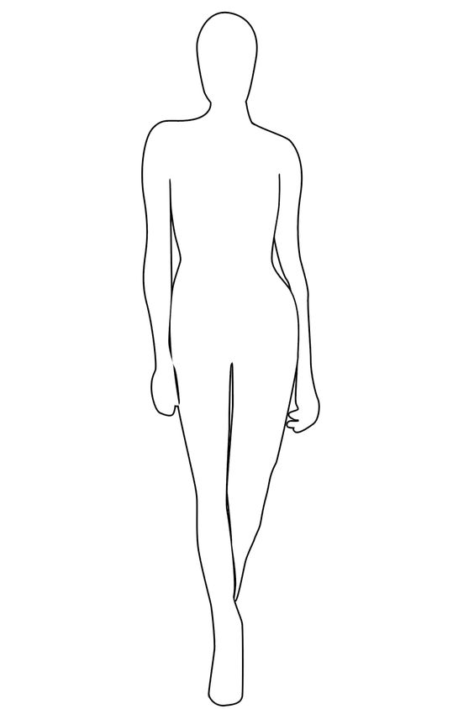

|  |  |  |
| --- | --- | --- |
| 1 | Bust: |  |
| 2 | Waist: |  |
| 3 | Hips: |  |
| 4 | Girth: |  |
| 5 | Arm Length: |  |
| 6 | Upper Arm: |  |
| 7 | Lower Arm: |  |
| 8 | Wrist: |  |
| 9 | Shoulder: |  |
| 10 | Thigh: |  |
|  |  |  |



**9**

**4**

**5 1 6**

**2 7**

**3**

**10 8**

MEASUREMENTS

Measurements taken over a leotard, undergarments or bathing suit are preferred. Do not measure yourself, allow someone else to do it for you. The measuring tape should not be pulled nor should be loose.

1. **Bust:**

Measure with arms held out at shoulder height, over the bust and around the back.

1. **Waist:**

Measure around the natural waistline, which is the narrowest point below the ribcage and directly above the belly button.

1. **Hips:**

Measure around the widest part of the buttocks.

1. **Girth:**

Measure from top of shoulder down front of the body through crotch and back up to same shoulder. Allow tape measure to go around the curves instead of being pulled tight.

1. **Arm Length:**

Measure from the tip of shoulder bone, down a straight arm, to the wrist bone.

1. **Upper Arm:**

Measure around the bicep.

1. **Lower Arm:**

Measure around forearm midway between the elbow and wrist.

1. **Wrist:**

Measure around the wrist bone.

1. **Shoulder:**

Measure from tip of right shoulder bone to tip of left shoulder bone.

1. **Thigh:**

Measure around thigh about two inches below the buttock.